Suggested Plants for Fort Collins, Colorado
by Felix Wong (http://felixwong.com)

These plants have been selected for their hardiness, drought resistance (suitable for xeriscaping), and ability to derive in the clay soils of Fort Collins. They are all perennials for lowest maintenance (do not require replanting every year). Plants are listed in increasing order of maximum height.

Plant Name (Common) | Plant Name (Latin) | Type | Bloom Season (Month #; e.g. 01=Jan) | Light Requirements | Max Height | Photo | Native | When to Plant | Notes
Wooly Thyme | Thymus pseudolanuginosus | ground cover | 01 -12 | part sun - full | 01" | 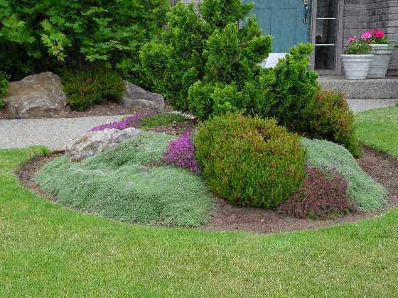 | - | early spring - early fall | -
Turkish Speedwell/Turkish Veronica | Veronica liwanensis | ground cover | 05 - 06 | part shade - full | 01-02" | 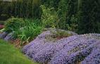 | no | - | -
Dragons Blood Sedum | Sedum spurium | ground cover | 07 - 08 | full | 03-08" | 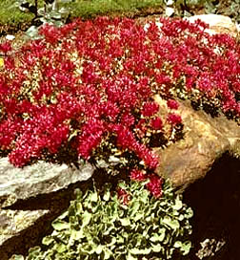 | - | - | spreads quickly
Hummingbird Flower | Lobelia cardinalis | perennial | 08 - 09 | full | 04-12" | 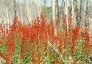 | - | - | -
Poppy Mallow | Callirhoe | perennial | 06 - early-07 | full | 06-12" |  | - | early spring or fall | -
Gazania | Gazania spp. | perennial | 06 - 09 | full | 06-12" | 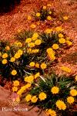 | - | - | -
Blue Fescue | Festuca glauca | ornamental grass | 01 -12 | part sun - full | 08-12" | 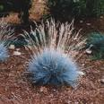 | - | spring - fall | -
Chocolate Flower | Berlandiera lyrata | perennial | 06 - 07 | full | 08-16" | 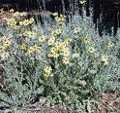 | yes | - | -
Little Bluestem | Schizachyrium scoparium | ornamental grass | 07 - 09 | full | 12-48" | 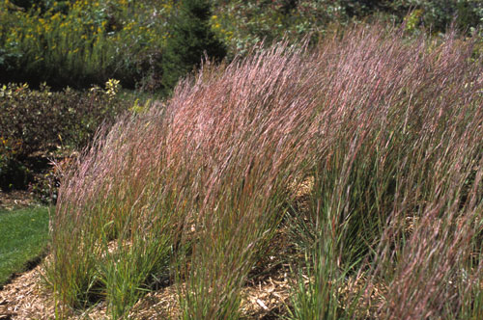 | yes | - | -
Autumn Joy Sedum | Sedum 'Autumn Joy' | perennial | 08 - 09 | full | 16-24" | 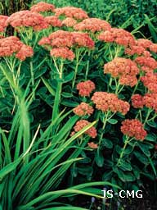 | no | spring - fall | -
Jupiter's Beard | Centranthus ruber 'Alba' | perennial | 05 - 06 | part shade - full | 18-36" | 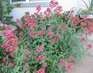 | - | - | -
Coneflower/Black Eyed Susan | Rudbeckia | wildflower | 08 - 09 | part sun - full | 24-30" | 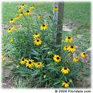 | - | spring - fall | -
Moonbeam Coreopsis | Coreopsis spp. | perennial | 06 - 10 | part sun - full | 24-30" | 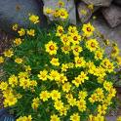 | - | spring/early summer | -
Tickseed Coreopsis | Coreopsis spp. | perennial | 06 - 10 | part sun - full | 24-30" | 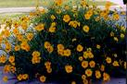 | - | spring/early summer | -
Red Hot Poker/Tritoma | Kniphofia uvaria | perennial | 05 - 07 | part shade - full | 24-30" | 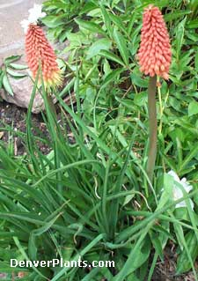 | no | - | -
Purple Coneflower | Echinacea purpurea | perennial | 07 - 08 | part shade - full | 24-36" | 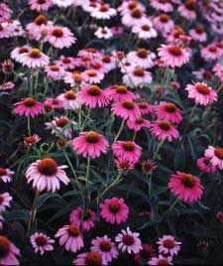 | - | early spring - early fall | -
Hyssop/New Mexican Hummingbird Mint | Agastache spp. | perennial | 07 - mid-10 | full | 24-36" | 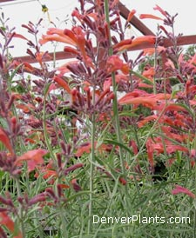 | no | spring - early fall | -
Blue Veronica Speedwell | Veronica spicata | perennial | 05 - 08 | part sun - full | 24-36" | 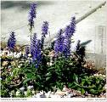 | - | spring - early fall | -
Blue Oat Grass/Blue Avena Grass | Helictotrichon sempervirens | ornamental grass | 01 -12 | full | 24-60" | 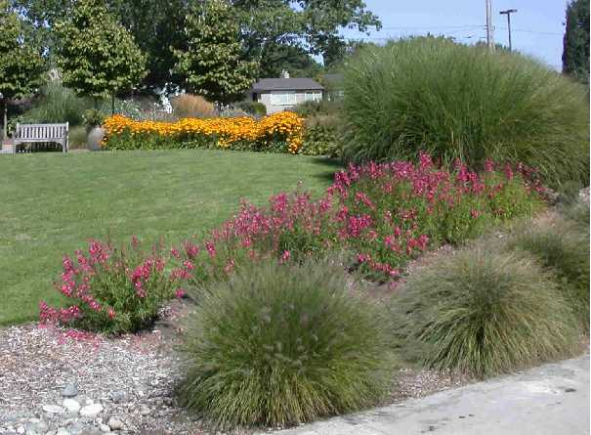 | no | spring - early fall | -
Foxglove/Pink Foxglove | Digitalis x mertonensis | perennial | 06 - 07 | part shade - full | 30-36" | 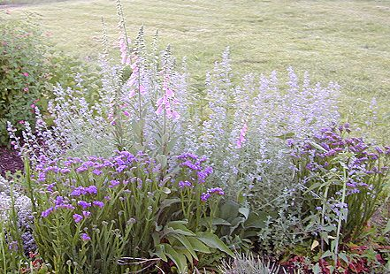 | no | - | -
Blazing Star/Gayfeather | Liatris spicata | perennial | 07 - 09 | full | 36" | 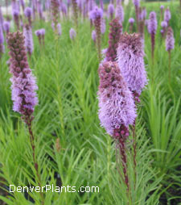 | - | spring - early fall | -
Azure Sage/Hardy Sage | Salvia azurea 'Grandiflora' | perennial | 07 - '09 | full | 36-48" | 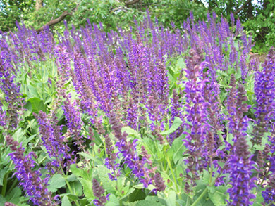 | no | - | -
Russian Sage | Perovski atriplicifolia | perennial | 07 - 09 | full | 36-48" | 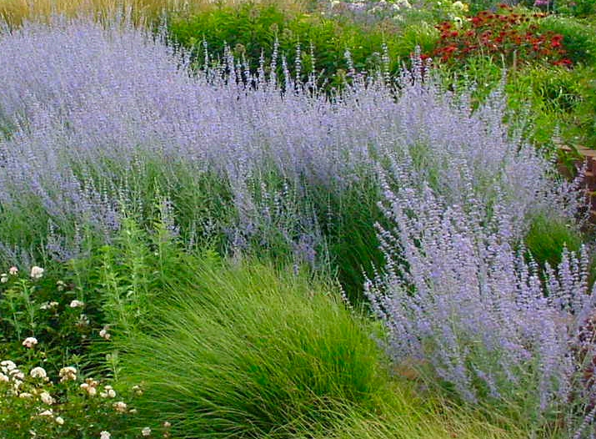 | no | spring - early fall | -
Penstemon Species | Penstemon spp. | perennial | 06 - 10 | full | various | 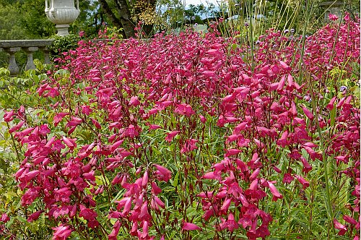 | - | spring/early summer | -
Blue Mist Spirea | Caryopteris incana | shrub | 07 - 08 | part sun - full | 24-48" | 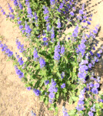 | - | spring - early fall | -
Cranberry Cotoneaster | Cotoneaster spp. | shrub | 05 - 06 | part shade - full | 24-96" | 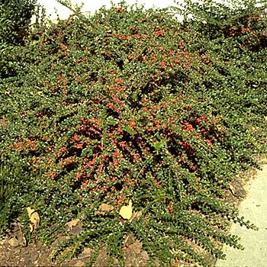 | - | - | -
Carol Macke Daphne | Daphne x burkwoodii 'Carol Macke' | shrub (evergreen) | 05 - 06 | part shade | 36-48" | 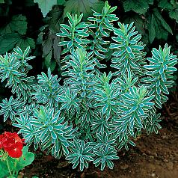 | - | - | very fragrant, slow growing; keeps most of its leaves all winter
Dwarf Snowflake Mockorange | Philadelphus x virginalis | shrub | 05 - 06 | part shade - full | 36-48" | 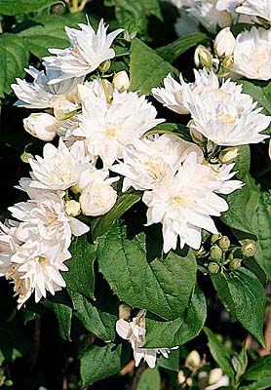 | - | year-round for container plants | orange-like fragrance; moderate growing
Grefsheim Spirea | Spiraea x cinerea | shrub | 04 | full | 48-60" |       

